Exercise 1: Mocking and Stubbing

Step -1:- Created a mock object for the external API.

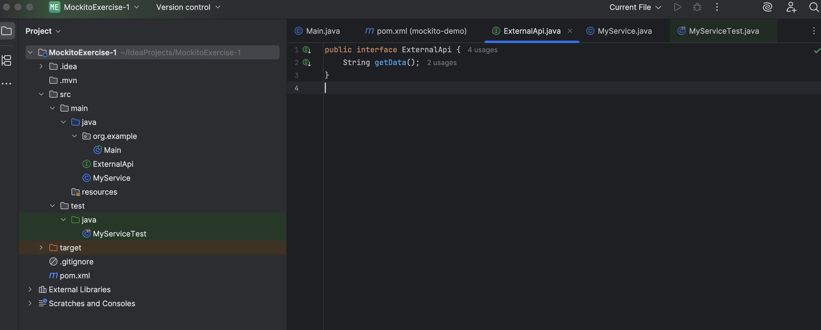

Step -2:-

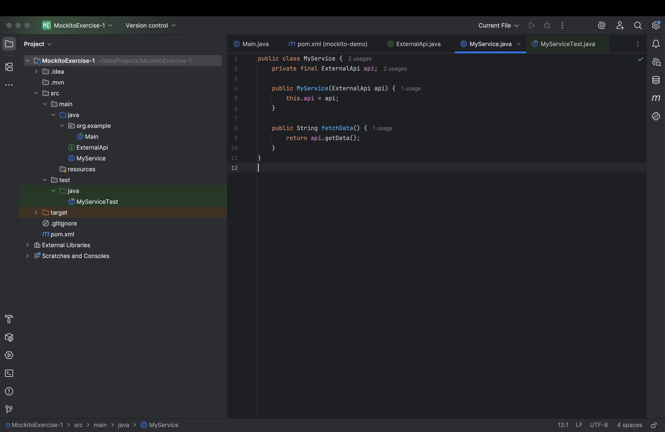

Step-3:-

Created a test case that uses the mock object.

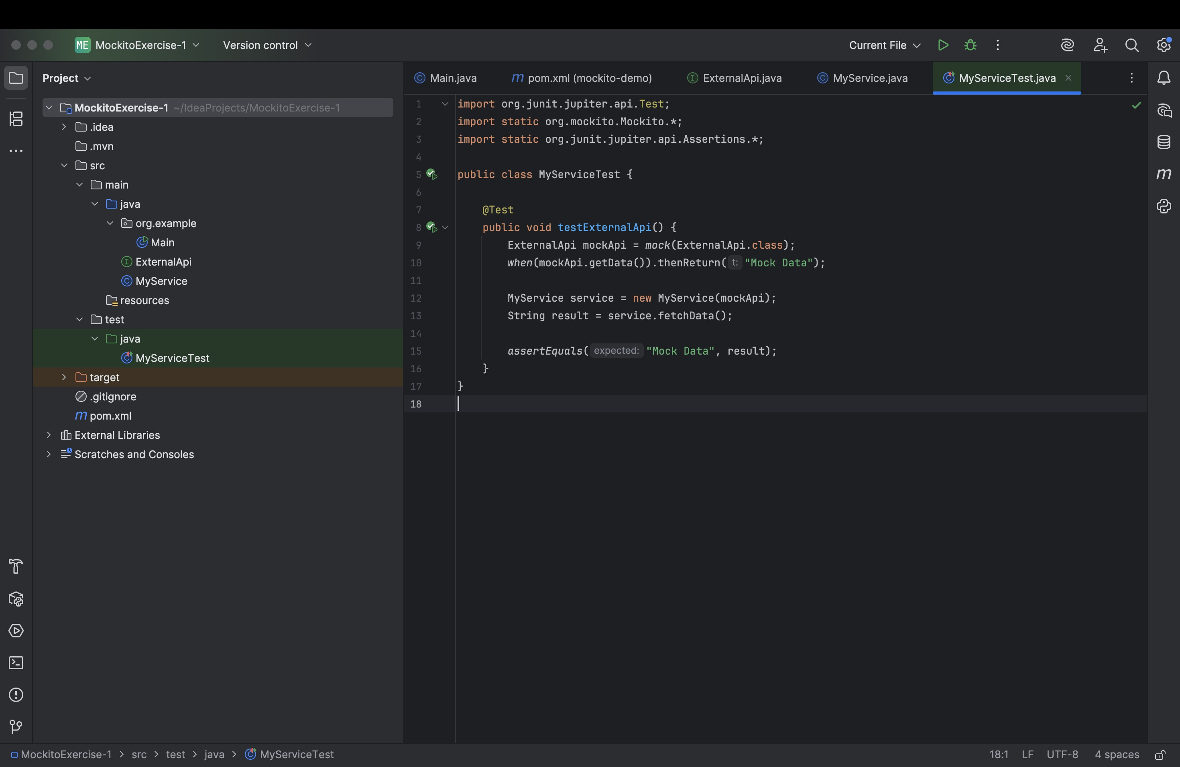

Output:-

